**ANALOG CIRCUIT DESIGN**

**IN-PHASE VOLTAGE BOOSTER (1.5V-6V)**

**PROBLEM BASED LEARNING**



**PERFORMED BY-**

1. **KETA MODI- 17070123062**
2. **MRIDUL KINGER- 17070123063**
3. **RHEA MUKHERJEE- 17070123064**
4. **NAMRATA TADANKI- 17070123065**
5. **RAMYA BARDAE- 17070123080**

**ANALOG CIRCUIT DESIGN**

**REPORT**

**PROBLEM STATEMENT-**

Given two operational amplifiers, design an in-phase voltage booster to boost an input of 1.5V to 6V.

**THEORY-**

An Operational Amplifier, or op-amp for short, is fundamentally a voltage amplifying device designed to be used with external feedback components such as resistors and capacitors between its output and input terminals. Generally op-amp IC 741 is used.

It is an 8 pin IC with 2 input terminals namely the inverting and non-inverting terminal and one output terminal. The pin diagram of the op-amp is as follows-

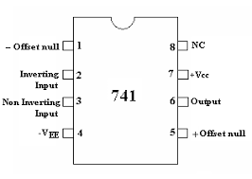

Op-amps have many practical applications which include amplifiers, comparators, oscillators, etc.

To achieve the desired output, the first op-amp is used as a closed loop non-inverting amplifier of gain Av and the second op-amp is used as a voltage follower.

Closed loop non-inverting amplifier- A closed loop non-inverting amplifier circuit produces an amplified version of the given input at the output without any phase change, i.e., input and amplified output are in phase. Since it is a closed loop circuit, degenerative feedback from output is given back to the input.

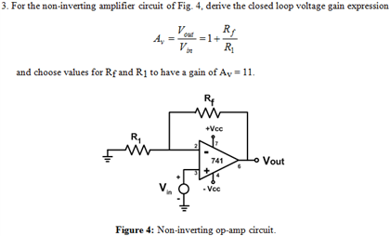

Gain of a closed loop non-inverting amplifier= **Av= Vout/Vin= 1 + (Rf/Ri).**

Where, Rf= feedback resistor and Ri= input resistor.

In the given problem statement, Vout=6V and Vin=1.5V. Therefore, the gain Av=Vout/Vin=4. To design an amplifier of gain 4, 1 + (Rf/Ri) must be equal to 4. So we can conclude that **Rf=3*Ri** in order to get the desired output.

Therefore, the first op-amp is designed as a closed loop non-inverting amplifier where Rf=3*Ri so the amplifier gain becomes equal to 4.

Voltage follower- Voltage Follower is simply a circuit in which output follows the input, means output voltage remains same as input voltage. It is also commonly known as Unity gain Op-amp Amplifier or Op-amp Buffer.

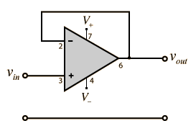

The input is given to the non-inverting terminal. So, the output will be in phase with the input. There is degenerative/negative feedback with no feedback resistor (Rf).

For the given problem statement, the entire amplification is done by the first op-amp. Hence the second op-amp is used as a voltage follower so as to obtain a final output voltage of 6V.

**MATERIALS REQUIRED-**

Two op-amps (IC 741), 1Kohm resistors, breadboard, wires, function generator, CRO, power supply, LTspice and KiCad (for electronic circuit design and simulation).

**PROCEDURE FOLLOWED-**

1. LTspice-

* Firstly, the circuit meeting the requirements of the problem statement was designed and implemented in LTspice.
* The circuit implemented in LTspice is attached below-

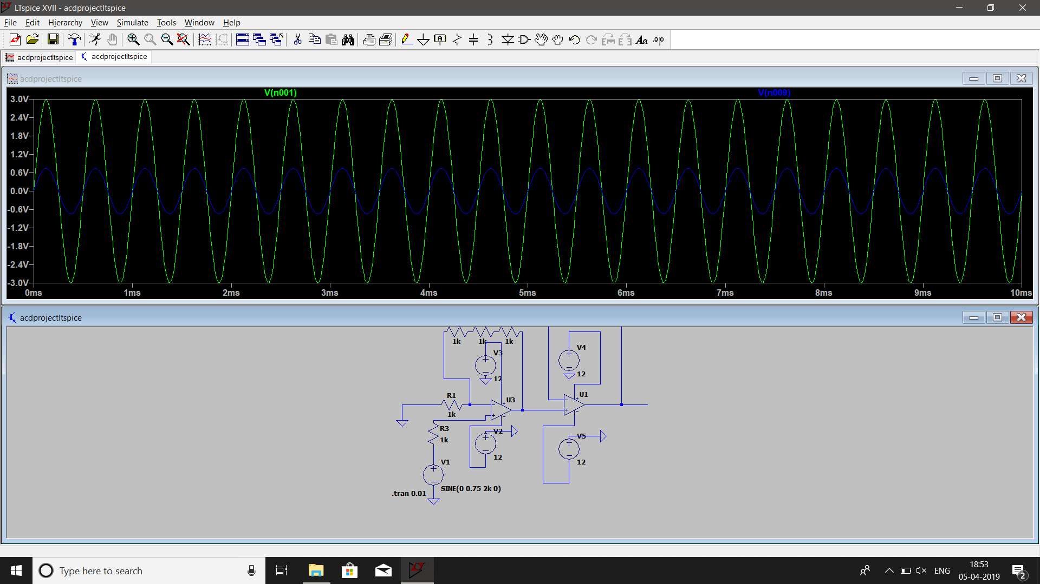

* The required input voltage of 1.5V, 2KHz frequency is given to the circuit. Input resistance (Ri) is taken as 1Kohm and feedback resistance (Rf) = 3*Ri = 3Kohm is implemented by taking three 1K resistors in series. The DC offset is set to 0.
* The output of the 1st op-amp which acts as the closed loop non-inverting amplifier is given as the input to the 2nd op-amp which acts as a voltage follower. The final output is taken from the 2nd op-amp.
* The output observed after simulating the circuit in LTspice is as shown below-

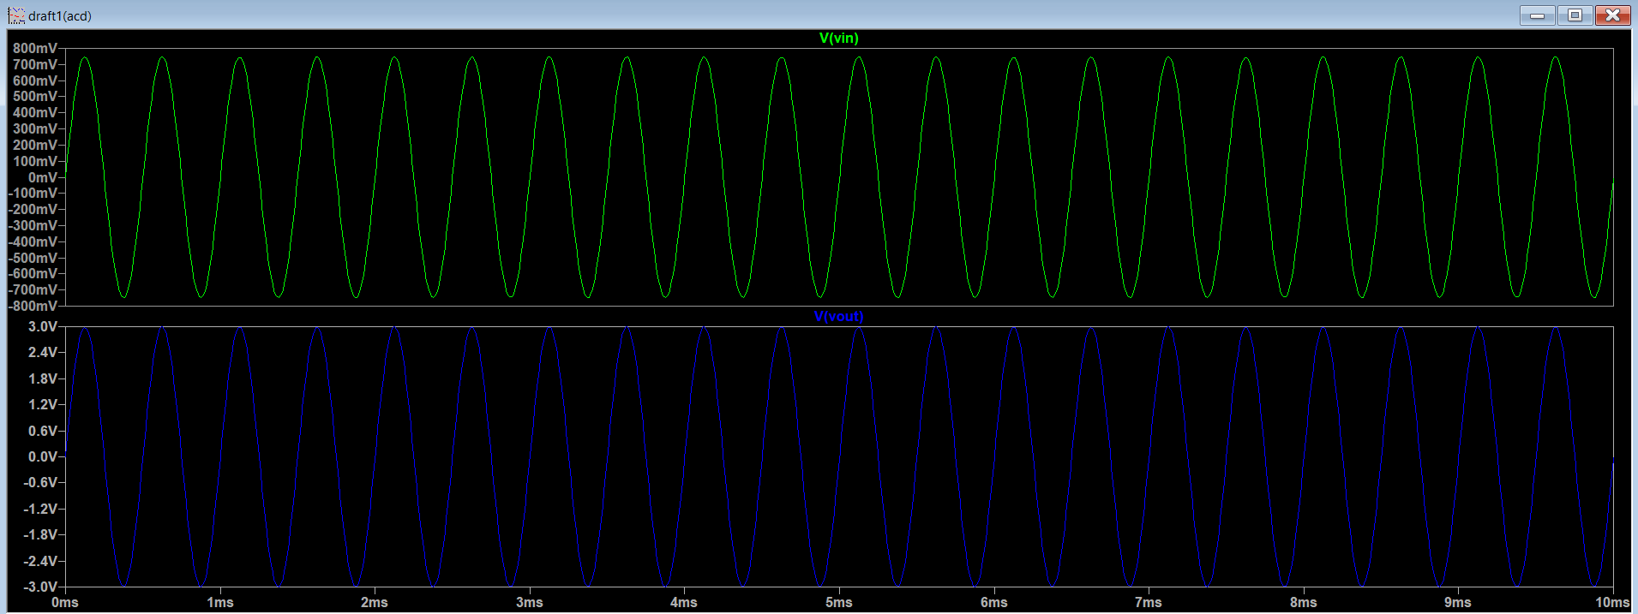

* The output observed on the LTspice output screen matches the desired output value of 6V. Hence, we concluded that our circuit is correct.

1. KiCad-

* First, Eeschema (schematic editor of KiCad) was used to generate the schematic circuit diagram of the desired circuit. This was done by adding all the components and making the necessary condition in the schematic window. The final schematic is attached below-

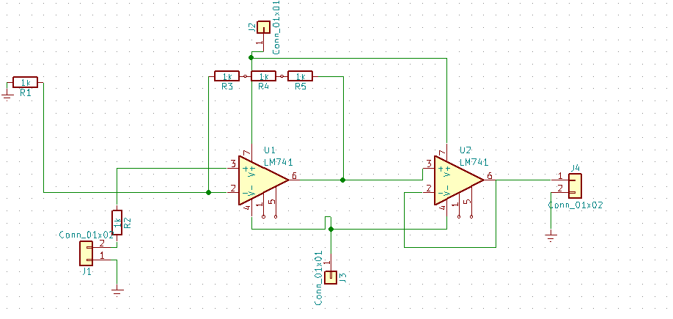

* The components were annotated using ’schematic annotation’ button.
* Electrical rules check was performed using ‘schematic electrical rules check’ button.
* For each component listed, footprints are allocated. The footprint allocation of each component is attached below-

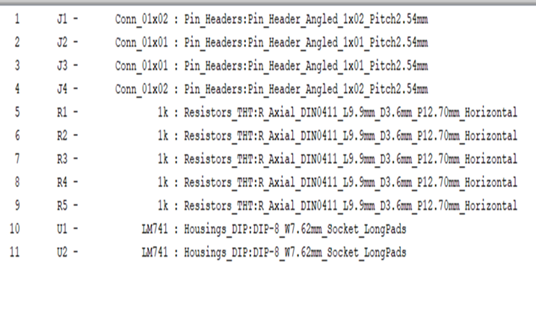

* Next step is to generate a netlist of the components using ‘Netlist generation’ button and save it,
* We then opened the pcb editor using the ‘Run Pcbnew’ button from the schematic editor. The schematic is then linked to the pcb editor by reading the netlist generated in the previous steps.
* The components were rearranged to resemble the circuit we designed. This is done by routing the tracks. 2 layers were used- first was a copper layer (where we do the soldering) and second was a component layer (opposite side of the board where components are placed).
* The final PCB editor looks as follows-

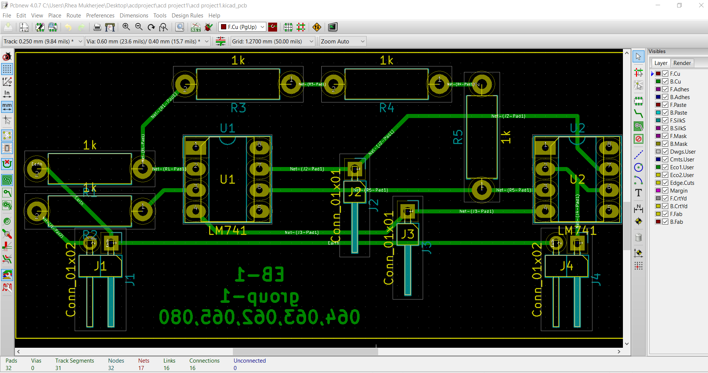

* The last step is to generate a gerber file. The gerber file looks as follows-

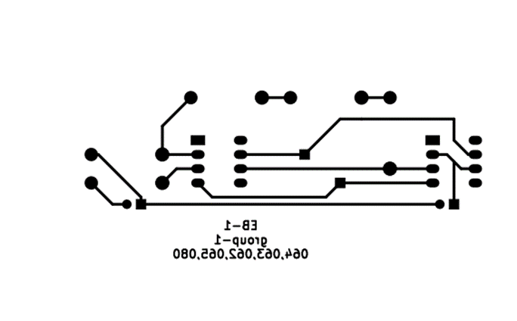

1. Etching of copper clad-

* The first step is to transfer the gerber file design onto the copper clad. We did this using toner transfer.
* The copper clad was cleaned using isopropyl solution.
* The final gerber file was printed onto a glossy paper. The ink was then transferred onto the copper clad by placing the printed glossy paper on the copper clad and then ironing it.
* In the places where the tracks were not formed clearly, a permanent marker was used to trace the tracks.
* The next step was etching of the copper clad. An etching solution made of hydrochloric acid (HCl) and hydrogen peroxide (H2O2) was used in the proportion 23% and 35% respectively mixed with some distilled water. The PCB is immersed in the etching solution.
* Due to displacement reaction taking place in the solution, the copper between the traces gets removed. When all the copper between the traces is gone, the etching process is complete.
* Next, we drilled holes in the PCB to place the components.
* The components, i.e., IC 741, 1Kohm resistors and wires, were placed on the PCB to make the correct circuit and were then soldered to finish the connections.
* The final PCB image is attached below-

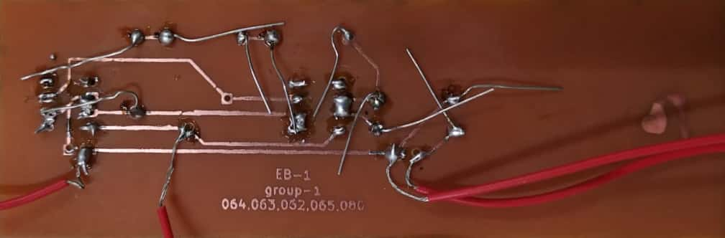

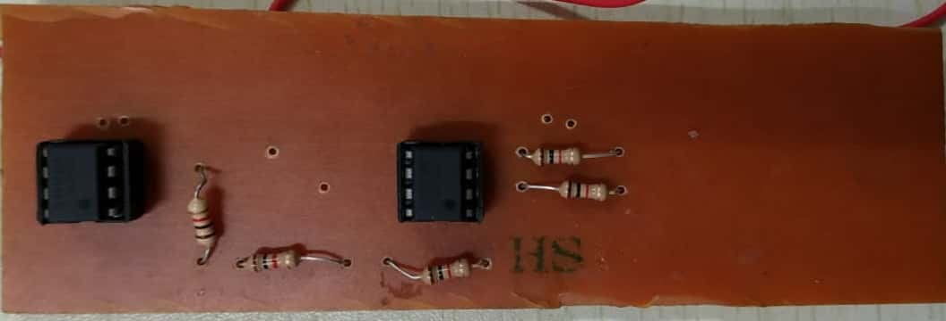

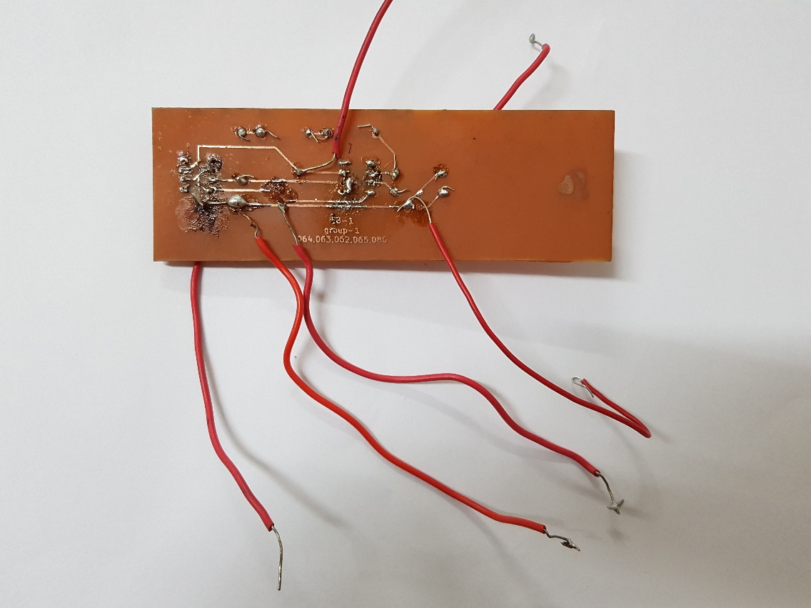

**OBSERVATION AND CONCLUSION-**

* The completed PCB was tested in the lab by giving a 1.5V, 2KHz frequency input from the function generator.
* The output was observed on the CRO. However, the output was a distorted waveform with lot of noise.
* The reason behind this was initially thought to be shorting of the board. However later after checking all connections, the conclusion for not getting an output is faulty wires which contribute to a lot of noise.

**RESULT-**

An in-phase voltage booster was implemented using 2 op-amp IC 741’s. The 1st op-amp was used as a non-inverting closed loop amplifier and the 2nd op-amp was used as a voltage follower. The circuit was implemented in KiCad, LTspice as well as on the PCB. Appropriate output waveform was observed during the LTspice simulation however when the PCB was tested, an output with excessive noise caused due to faulty wires was observed on the CRO.